COMPUTER NETWORKS
Week 3 Study Notes

Chapter 1: LAN Interconnection
LAN (Local Area Network) interconnection is the process of connecting multiple LANs to enable communication across larger networks. Before understanding how devices interconnect LANs, it is important to understand why a single large LAN is not practical.

1.1 Why Not One Big LAN?
A single large LAN faces several serious problems:
- Limited traffic capacity — all stations must share the same bandwidth. As more devices join, performance drops.
- Limited cable length — for example, IEEE 802.3 (Ethernet) defines a maximum cable length. A single LAN cannot span large distances.
- Large collision domain — in a shared medium, any two stations can collide. More devices mean more collisions and retransmissions.
- Limited number of stations — in IEEE 802.5 (Token Ring), every station introduces token-passing delay. Too many stations make the network slow.

⚑ Key Concept: Collision Domain
- A collision domain is a network segment where two or more devices can send signals at the same time and cause a collision.
- Smaller collision domains mean fewer collisions and better performance.
- Network devices like bridges and switches help reduce collision domains.

1.2 Network Devices and OSI Layers
Different interconnection devices operate at different OSI layers. The layer at which a device operates determines what information it uses to make forwarding decisions.

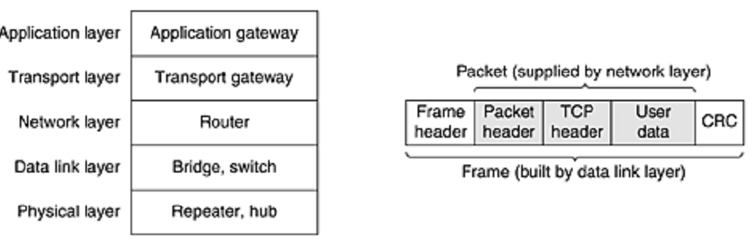
Figure 1.1: Network devices at different OSI layers — each device uses information from its layer to decide how to forward data. CRC (Cyclic Redundancy Check) is used for error detection at the data link layer.

Device | OSI Layer | What It Reads | Forwarding Based On
Repeater / Hub | Layer 1 (Physical) | Electrical signals (Volts) | Amplifies signal — no intelligence
Bridge / Switch | Layer 2 (Data Link) | Ethernet frame headers (MAC address) | Destination MAC address
Router | Layer 3 (Network) | IP packet headers | Destination IP address

Chapter 2: Repeaters and Hubs

2.1 Repeaters
Repeaters are the simplest LAN interconnection devices. They operate at the Physical Layer (Layer 1) and work purely with electrical signals.

Key characteristics of repeaters:
- No frame intelligence: Repeaters do not understand frames, packets, or headers. They only understand voltage (electrical signals).
- Signal amplification: They regenerate (amplify) electrical signals to extend cable length.
- Extended cable length: Classic Ethernet (802.3) allows up to 4 repeaters, extending the maximum cable length from 500 metres to 2,500 metres.

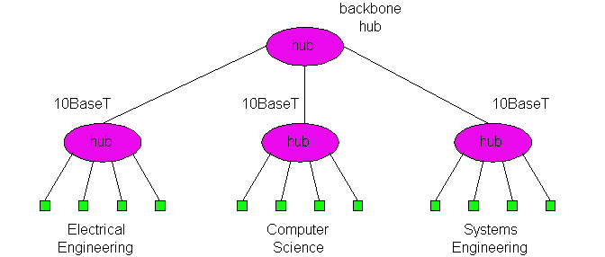
Figure 2.1: A repeater extends network cable length by regenerating electrical signals.

2.2 Hubs
Hubs are essentially multi-port repeaters. They connect multiple LAN segments and broadcast signals to all connected ports.

Important points about hubs:
- LAN segments: Each port on a hub connects to a LAN segment.
- No collision isolation: Hubs do not isolate collision domains. A node on any segment can collide with a node on any other segment.
- Multi-tier (hierarchical) design: Hubs can be arranged in a hierarchy, with a backbone hub at the top. This is called a multi-tier hub design.

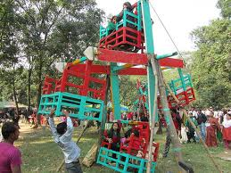
Figure 2.2: Hub hierarchy — hubs can be stacked in multiple tiers with a backbone hub at the top for extended coverage.

2.2.1 Hub Advantages
- Simple and inexpensive to deploy.
- Graceful degradation: In a multi-tier hub design, if one hub fails, the rest of the LAN continues to operate. The network degrades slowly rather than failing completely.
- Distance extension: Each hub extends the maximum distance between node pairs by up to 100 metres.

⚑ Important: Hub Limitation
- Hubs do NOT reduce collision domains. All devices connected through hubs share one large collision domain.
- This means every device competes for bandwidth, and performance degrades significantly as more devices are added.
- Hubs are largely replaced by switches in modern networks.

Chapter 3: Bridges

3.1 What Is a Bridge?
Bridges are Layer 2 (Data Link Layer) devices. Unlike hubs, bridges examine the frame header to make intelligent forwarding decisions.

Key characteristics:
- Frame examination: A bridge reads the destination MAC address in each Ethernet frame header.
- Selective forwarding: It only forwards a frame to the segment where the destination device lives — not to all segments.
- Collision domain isolation: Each port on a bridge is its own collision domain. This is the main advantage over hubs.
- Buffering: A bridge buffers (temporarily stores) frames. This allows it to regulate traffic between segments.
- CSMA/CD: When forwarding a frame to a segment, the bridge uses CSMA/CD (Carrier Sense Multiple Access with Collision Detection) to access the medium.

3.2 Bridge Structure and Line Cards
A modern bridge is built with line cards — one for each input/output line:
- A bridge typically has four to eight input lines with corresponding line cards.
- Each line card handles one type of network (e.g., an Ethernet line card cannot handle Token Ring frames).
- Mixed network types: A single bridge may have line cards for different network types and speeds, making it versatile.
- Each line = its own collision domain: Unlike a hub where all ports share one collision domain, each bridge port has its own. This greatly reduces collisions.

3.3 Backbone Bridge Design
A backbone bridge is a central bridge that interconnects multiple smaller LANs or segments. It forms the core of a multi-segment network.

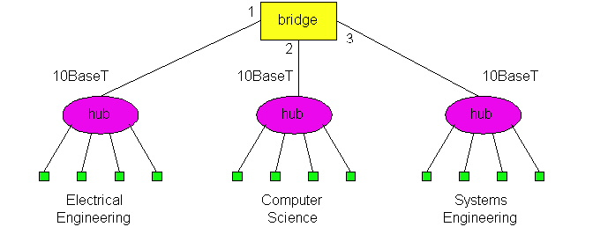
Figure 3.1: Backbone bridge connecting multiple LAN segments — the bridge acts as the central switching point.

3.4 Interconnection Without a Backbone
It is possible to connect LANs without a dedicated backbone bridge, but this approach is NOT recommended due to two critical problems:
- Single point of failure: If the Computer Science (CS) hub fails, the entire path between departments is lost.
- Traffic bottleneck: All traffic between the EE and SE departments must travel through the CS segment, creating unnecessary congestion.

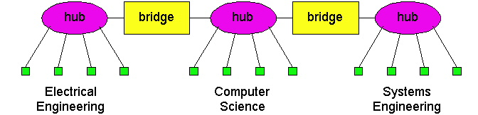
Figure 3.2: Network without a backbone bridge — creates single point of failure and traffic bottleneck through one segment.

Chapter 4: Bridge Learning and Filtering

4.1 How Does Bridge Learning Work?
Bridges use a process called self-learning to build a forwarding (filtering) table. This table maps MAC addresses to the port (interface) on which that device can be reached.

4.1.1 Step-by-Step Example: C sends a frame to D
Initial state: The bridge has no entries in its table.

- C sends frame: The bridge receives the frame but has no entry for D's address. It floods the frame to both LANs (sends on all ports).
- Bridge learns C: The bridge notes that C's frame arrived on interface/port 1. It records: C → Port 1.
- Frame delivery: The frame is ignored on the upper LAN (D is not there) but received and accepted by D on the lower LAN.

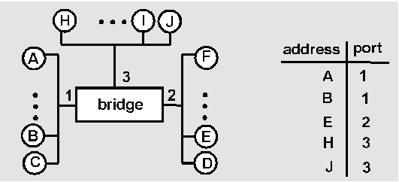
Figure 4.1: Bridge learning — the bridge floods the first frame and records the source port. Subsequent frames to known addresses are forwarded selectively.

4.1.2 D Replies to C
- D sends a reply frame to C.
- Bridge learns D: The bridge sees D's frame arriving on interface 2. It records: D → Port 2.
- Selective forwarding: The bridge already knows C is on port 1, so it only forwards the reply frame out of port 1. No flooding is needed.

⚑ Bridge Filtering Table (After Learning)
- C → Port 1 (learned from C's outgoing frame)
- D → Port 2 (learned from D's reply frame)
- Any future frame for C is forwarded only to Port 1 — not flooded.
- Any frame for an unknown destination is still flooded to all ports.

4.2 Problem: What Happens With Loops?
If two bridges are connected to the same two LAN segments (creating a loop), serious problems occur:
- Incorrect learning: The bridge may learn the same MAC address on multiple ports, causing incorrect forwarding decisions.
- Frame duplication: A single frame may be duplicated and forwarded infinitely around the loop.
- Broadcast storms: Flooded frames loop forever, consuming all bandwidth.

4.3 Solution: Loop-Free Tree (Spanning Tree)
A loop-free logical tree structure ensures there is only one path between any two nodes. In a tree:
- Every message from A marks A's location at each bridge it passes through.
- Subsequent messages to A follow the marked path — no looping occurs.
- The tree structure guarantees a single, deterministic path between any source and destination.

Chapter 5: Spanning Tree Protocol (STP)

5.1 Why Spanning Tree?
In real networks, redundant paths are necessary for reliability. However, multiple paths between bridges create loops. The Spanning Tree Protocol resolves this conflict.

The core problem:
- Redundant paths between source and destination are desirable for fault tolerance.
- Multiple active paths cause loops — bridges may duplicate and forward frames forever.
- Solution: Organize bridges in a spanning tree by disabling selected interfaces, eliminating loops while preserving connectivity.

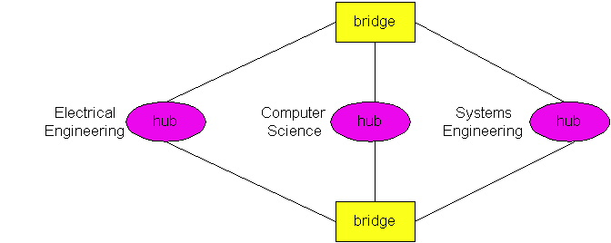
Figure 5.1: Spanning Tree in action — selected interfaces are disabled (shown as 'Disabled') to break loops while maintaining full network connectivity.

5.2 Spanning Tree Protocol Details
The Spanning Tree Protocol works as follows:
- Loop-free path: STP allows exactly one active path between any two LANs, eliminating loops.
- BPDUs: Bridges communicate using special messages called Bridge Protocol Data Units (BPDUs). These messages are used to elect a root bridge and determine which interfaces to disable.
- IEEE Standard: STP is standardized under IEEE 802.1D.

⚑ Spanning Tree — Key Terms
- Root Bridge: The central bridge elected as the 'root' of the spanning tree.
- BPDU (Bridge Protocol Data Unit): Special control messages bridges use to communicate STP information.
- Designated Port: The active port on each LAN segment.
- Blocked Port: A port that is disabled to prevent loops.
- IEEE 802.1D: The IEEE standard that defines the Spanning Tree Protocol.

Chapter 6: Bridges vs. Routers

6.1 Similarities
Both bridges and routers are store-and-forward devices. This means they fully receive a frame or packet before forwarding it to the next hop.

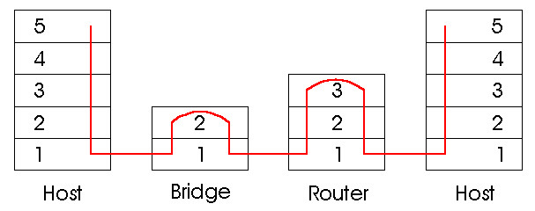
Figure 6.1: Bridges and routers in a network — bridges operate at Layer 2 (Data Link), routers operate at Layer 3 (Network).

6.2 Key Differences
Feature | Bridge | Router
OSI Layer | Layer 2 (Data Link) | Layer 3 (Network)
What it examines | Ethernet frame header (MAC address) | IP packet header (IP address)
Tables maintained | Filtering table (MAC to port) | Routing table (IP to next hop)
Algorithms used | Filtering, learning, spanning tree | Routing algorithms (OSPF, RIP, BGP)
Topology support | Restricted — spanning tree required to avoid cycles | Arbitrary topologies supported
Loop prevention | Spanning Tree Protocol (disables ports) | TTL counters + routing protocols
Broadcast storms | Forwarded — no protection offered | Blocked — provides firewall protection
Configuration | Plug and play (no IP config needed) | Requires IP address configuration
Processing overhead | Low (simpler operation) | Higher (more complex processing)
Best for | Small networks (up to ~200 hosts) | Large networks (thousands of hosts)

6.3 When to Use Bridges vs. Routers
Choosing between bridges and routers depends on network size and requirements:

⚑ Bridges: Advantages & Disadvantages
- + Simpler — requires less processing power
- + Plug and play — no manual IP configuration
- − Restricted topology — must use spanning tree to avoid loops
- − No broadcast storm protection — will forward endless broadcasts
- Best used in: Small networks with a few hundred hosts

⚑ Routers: Advantages & Disadvantages
- + Supports arbitrary network topologies (no spanning tree needed)
- + Limits loop propagation using TTL (Time to Live) counters
- + Provides firewall protection against broadcast storms
- − Requires IP address configuration — not plug and play
- − Requires higher processing power
- Best used in: Large networks with thousands of hosts

Chapter 7: Ethernet Switches

7.1 What Is an Ethernet Switch?
Ethernet Switches are advanced Layer 2 devices that combine the best features of bridges while connecting individual host computers rather than whole LAN segments.

Key characteristics:
- Layer 2 forwarding: Switches use MAC (LAN) addresses to make forwarding decisions — just like bridges.
- Simultaneous connections: A switch allows multiple simultaneous connections. For example, A to B and A' to B' can communicate at the same time with no collision.
- No collisions: Each port is its own collision domain. Devices connected to different ports never collide with each other.
- Large number of interfaces: Switches are designed with many ports to support individual host connections in a star topology.
- Star topology: Each individual host connects directly to the switch port — a star-connected design.

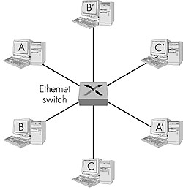
Figure 7.1: Ethernet switch in a star topology — each host connects directly to its own dedicated switch port, eliminating collisions.

7.2 Cut-Through Switching
Cut-through switching is an advanced forwarding technique used by switches:
- The switch begins forwarding a frame as soon as it reads the destination MAC address — without waiting for the entire frame to arrive.
- Reduced latency: This results in a slight but measurable reduction in end-to-end delay compared to store-and-forward.
- This is useful for applications that require very low latency, such as real-time communications.

7.3 Dedicated vs. Shared Interfaces
Switch ports can operate in two modes:
- Dedicated: The full bandwidth (e.g., 100 Mbps) is reserved exclusively for one device. No sharing, no collisions.
- Shared: Bandwidth is shared among multiple devices. Still better than a hub since each shared group is isolated from others.

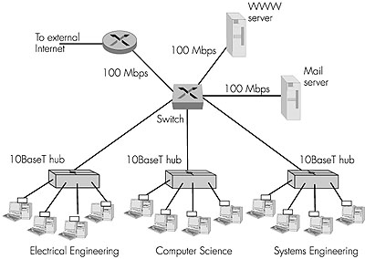
Figure 7.2: Dedicated vs. Shared switch interfaces — dedicated ports give each host exclusive bandwidth; shared ports divide bandwidth among connected devices.

7.4 Switches vs. Bridges
Switches and bridges are fundamentally similar — both forward based on MAC addresses. However, there are important practical differences:

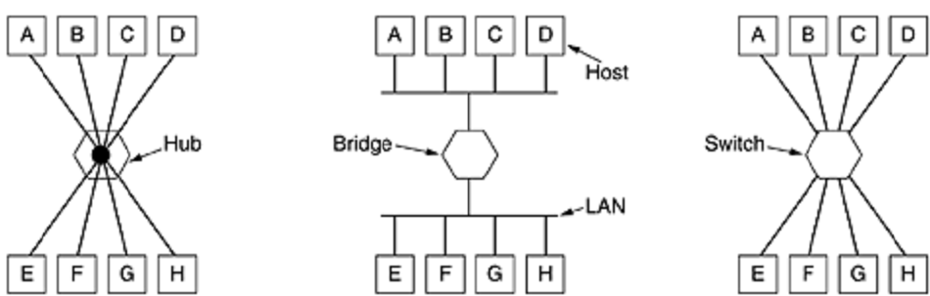
Figure 7.3: Switch vs. Bridge forwarding — in a bridge network (middle), the bridge may discard frames when source and destination are on the same segment. In a switch network (right), the switch must actively forward every frame since each host has its own dedicated port.

Feature | Bridge | Switch
Primary purpose | Connect LAN segments | Connect individual computers
Forwarding basis | MAC address (frame) | MAC address (frame) — identical
Number of ports | Few (4–8 typically) | Many (12, 24, 48+ ports common)
Port collision domain | One per port | One per port — same as bridge
Frame forwarding | May discard if on same segment | Must actively forward all frames
Buffer space | Per line card | Per port — more buffer needed
Frame loss risk | Low | Possible if frames arrive faster than they are retransmitted

7.5 Buffer Management in Switches
Since each switch port connects to a single computer, switches need significantly more buffer space than bridges:
- Each line card in a switch provides buffer space for frames arriving on its port.
- Collision-free: Since every port is its own collision domain, switches never lose frames to collisions.
- Buffer overflow risk: If frames arrive faster than they can be retransmitted, the switch may run out of buffer space and must discard (drop) frames.

Chapter 8: FDDI — Fiber Distributed Data Interface

8.1 What Is FDDI?
FDDI (Fiber Distributed Data Interface) is a standard for data transmission in a local area network over long distances.

Basic facts:
- Physical medium: Uses optical fiber as the standard medium. A copper-based variant is called CDDI (Copper Distributed Data Interface), also known as TP-PMD (Twisted-Pair Physical Medium-Dependent) or TP-DDI.
- Speed: Provides 100 Mbit/s optical data transmission.
- Range: Can extend up to 200 kilometres (120 miles).
- Scale: Supports thousands of users across large geographical areas.
- Protocol basis: Although FDDI uses a ring-based token network topology, it is NOT based on IEEE 802.5 (Token Ring). Instead, it is derived from IEEE 802.4 (token bus timed token protocol).

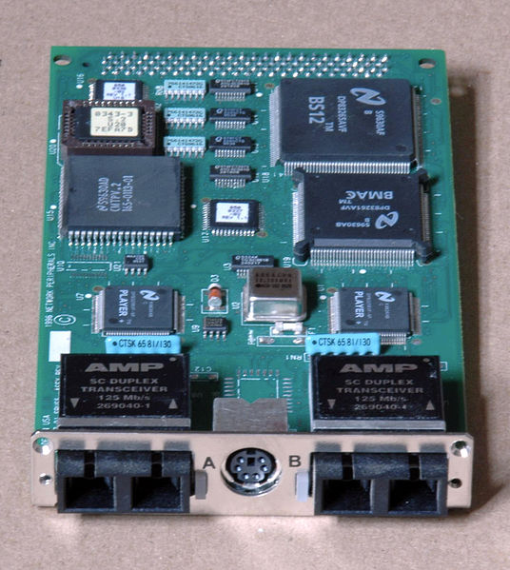
Figure 8.1: Dual-attach FDDI card with SC connectors and a DIN connector for an external optical bypass unit — used in high-reliability network infrastructure.

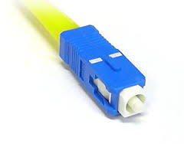
Figure 8.2: SC connector — the standard optical connector used in FDDI networks.

8.2 FDDI Ring Architecture
FDDI offers two station attachment types:

⚑ FDDI Station Types
- DAS (Dual-Attached Station): Connected to BOTH the primary ring and the secondary ring. Provides redundancy. Used for critical infrastructure devices.
- SAS (Single-Attached Station): Connected to only one ring (usually through a concentrator). Used for standard host computers.
- Concentrator: A special FDDI device that allows SAS devices to connect to the FDDI ring without having to be dual-attached.

8.3 Dual Ring Structure
FDDI uses a dual-ring architecture for reliability:
- Primary ring: The main active ring. Carries traffic at up to 100 Mbit/s.
- Secondary ring: A backup ring. Normally idle. If the primary ring fails, the secondary ring takes over automatically.
- Combined capacity: If the secondary ring is used for data (not just backup), the total capacity can reach 200 Mbit/s.
- Dual ring distance: A dual ring can extend up to 100 km (62 miles). A single ring can extend the maximum distance further.
- Frame size: FDDI supports a maximum frame size of 4,352 bytes — much larger than standard Ethernet's 1,500-byte maximum. This allows better effective data rates in some scenarios.

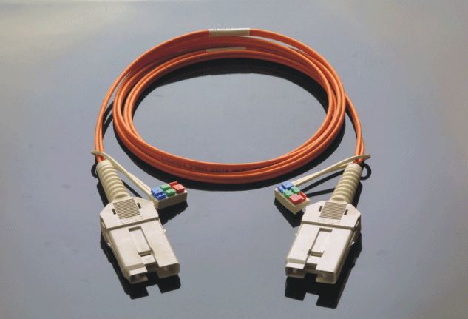
Figure 8.3: FDDI dual-ring architecture — the primary and secondary rings rotate in opposite directions. The secondary ring provides fault tolerance.

8.4 FDDI Topology Design
Dual Ring of Trees is the typical design used for FDDI networks:
- A small number of infrastructure devices (routers, concentrators) are dual-attached to both rings.
- Host computers connect as single-attached devices to concentrators or routers.
- The dual ring in its simplest form collapses into a single device.
- Typically, the entire dual ring is housed in a computer room. Some implementations use FDDI as a Metropolitan Area Network (MAN).

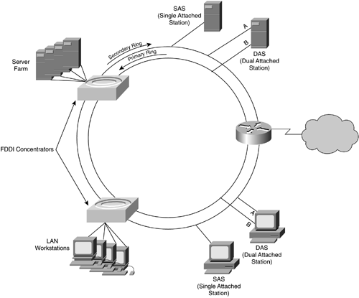
Figure 8.4: FDDI dual ring of trees topology — routers and concentrators form the dual ring core; host computers attach as single-attached devices to the concentrators.

Important constraints in the dual ring topology:
- The dual ring physically passes through each connected device. Every dual-attached device must remain continuously operational.
- Optical bypass unreliable: The standard allows for optical bypass switches to handle device failures, but network engineers consider these unreliable.
- Minicomputers excluded: Minicomputers are not suitable for connection to the dual ring because they are not under direct control of network engineers. A failed minicomputer can break the entire ring.

8.5 FDDI Frame Format
The FDDI frame contains the following fields in order:

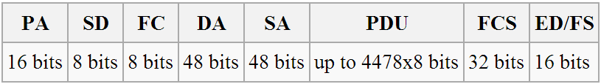
Figure 8.5: FDDI Frame Format — each field serves a specific role in frame identification, addressing, data, error checking, and status signalling.

Field | Full Name | Purpose
PA | Preamble | Synchronizes the receiver to the incoming signal
SD | Start Delimiter | Marks the beginning of the frame
FC | Frame Control | Identifies the type of frame (data, token, etc.)
DA | Destination Address | MAC address of the intended recipient
SA | Source Address | MAC address of the sender
PDU | Protocol Data Unit | The actual data payload (packet) being carried
FCS | Frame Check Sequence | Checksum for error detection (CRC)
ED | End Delimiter | Marks the end of the frame
FS | Frame Status | Indicates whether the frame was received and copied correctly

Chapter 9: Ethernet vs. Token Ring — Media Access Control

9.1 Two Approaches to Media Access
When multiple devices share a network medium, they need a method to decide who can transmit at any given time. Two primary approaches exist:

9.1.1 Contention-Based Access (Ethernet / CSMA/CD)
In contention-based access, devices compete for the right to transmit:
- How it works: Any device can transmit whenever the medium appears idle. If two devices transmit simultaneously, a collision occurs. Both stop and retry after a random wait time.
- Low utilization performance: Ethernet performs very well when network utilization is low. Few collisions occur, and devices transmit quickly.
- High utilization performance: As load increases, collisions and retransmissions increase. Performance degrades under heavy load.

9.1.2 Token Passing (Token Ring / FDDI)
In token passing, only the device holding a special token frame may transmit:
- How it works: A small control frame called a token circulates around the ring. Only the station holding the token may transmit. After transmitting, the station releases the token.
- High utilization performance: Token passing is superior under heavy load. There are no collisions, so bandwidth is used efficiently.
- QoS support: Token passing can prioritize certain applications (e.g., multimedia, voice) by giving them preferential access to the token.
- Modern uses: Token passing principles are used in USB, Firewire (IEEE 1394), and other shared media technologies.

Condition | Ethernet (Contention) | Token Ring (Token Passing)
Low network load | Excellent — fast, no waiting | Good — slight overhead from token passing
High network load | Degrades — many collisions | Excellent — no collisions, orderly access
Latency predictability | Unpredictable — depends on collisions | Predictable — bounded by token rotation time
QoS support | None — all devices equal | Yes — can prioritize specific applications
Complexity | Simple — devices decide independently | More complex — token management required

9.2 Response Time vs. Load
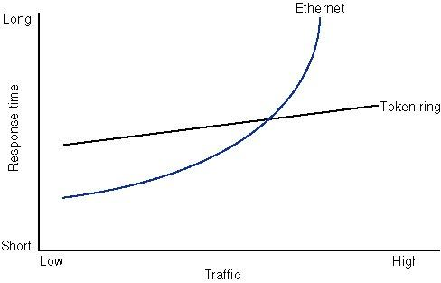
Figure 9.1: Response time vs. network load comparison — Ethernet response time rises sharply under high load due to collisions, while token ring maintains more stable response times. Token ring performs better at high utilization.

Key observations from the graph:
- At low load, Ethernet has very low response time — it is faster than token ring.
- At high load, Ethernet response time rises sharply and becomes unpredictable as collisions multiply.
- Token ring response time increases more gradually and remains bounded even at high load.
- Practical conclusion: Use Ethernet for low-to-medium load networks. Use token passing for networks requiring guaranteed bandwidth or predictable response time.

Chapter 10: Summary and Quick Revision

10.1 Key Concepts Summary
Device | Layer | Key Function | Collision Domain | Use Case
Hub | 1 | Broadcasts to all ports | One shared domain for all ports | Simple, low-cost small LANs (legacy)
Bridge | 2 | Selective forwarding by MAC | One per port (isolated) | Connecting LAN segments
Switch | 2 | High-speed MAC forwarding | One per port (isolated) | Connecting individual hosts
Router | 3 | IP-based forwarding | One per port (isolated) | Connecting large or different networks

10.2 Spanning Tree Protocol — Quick Facts
- Purpose: Prevents loops in networks with multiple bridges.
- Method: Disables selected bridge interfaces to create a loop-free tree topology.
- Standard: IEEE 802.1D.
- Messages: Uses BPDUs (Bridge Protocol Data Units).
- Result: Exactly one active path between any two LAN segments.

10.3 FDDI — Quick Facts
- Full name: Fiber Distributed Data Interface.
- Speed: 100 Mbit/s (200 Mbit/s with both rings active).
- Range: Up to 200 km (single ring); 100 km (dual ring).
- Frame size: Up to 4,352 bytes (vs. Ethernet's 1,500 bytes).
- Topology: Dual ring of trees — DAS devices on the core ring, SAS hosts on branches.
- Standard basis: Derived from IEEE 802.4 (not IEEE 802.5).

⚑ Exam Tips
- Remember: Hubs do NOT isolate collision domains. Bridges and switches DO.
- Spanning Tree Protocol disables ports — it does not remove physical links.
- FDDI secondary ring is normally idle — it activates only on primary ring failure.
- Cut-through switching starts forwarding before the whole frame arrives — reduces latency.
- Bridges are best for small networks; routers for large networks.
- Token passing has NO collisions; Ethernet uses CSMA/CD to manage collisions.

— End of Week 3 Study Notes —

